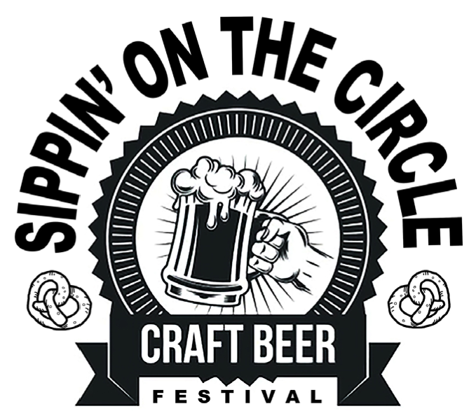
Food Court
Vendor Application
Information
2024
Presented by the Rotary Club of Highlands County & the Highlands Art League Saturday, April 20, 2024 on the Circle in Downtown Sebring from 1pm to 8pm.
Craft Beer, Domestic Beer, Wine, Spirits, Food Trucks, and the “Outta Hand Band.”
RAIN OR SHINE EVENT
We invite you to provide food service at our event.
If you plan to leave a trailer attached to your vehicle you will have to purchase a second space.

$125 for each 10’ x 28’ Space
$25 additionally for electrical (You provide
extension cords)

Acceptance is on a first come, first-serve basis.
It is our intention to not have duplicate offerings so please state the foods or beverages that you intend to sell.
No generators allowed.
If you need to connect to power, there is an additional $25.00 charge. You will be responsible for providing extension cords for your set-up.
Fire extinguishers are required and those will be checked by the Sebring Fire Dept.
Craft beers, wine, domestic beer, and spirits will be part of the event sponsored by Bernie Little Distributors and local breweries.
TO REGISTER: Complete form below, pay and submit
or
Download and print this application and mail with payment by April 1st to the Highlands Art League, PO Box 1693, Sebring, Florida 33871.
Application is a requirement for Highlands Art League, Rotary Club of Highlands County and the City of Sebring.

